Day 11:
Collection framework

Collection framework provided set of classes and interface which help to add the collection of object or element or data of any types. It provided lot of pre defined methods which help to add, remove, search, iterate, sort. Do functionality very easily. It is like a Data structure.
All those classes and interfaces are part of util package.
Collection framework hierarchy

Collection -- interface

Set List Queue Map

All 4 are interfaces. Set, List and Queue internally extends Collection. But Map doesn’t extends Collection.

Set: it is use to store collection of elements. Element can be order, unorder as well as sorted. Set doesn’t allow duplicate. Set doesn’t provide index concept.
Set classes: below 3 classes directly or indirectly implements Set interface.
HashSet
LinkedHashSet
TreeSet
List: it allows to store collection of elements. It allows duplicate element. It maintains order using index position.
List classes: below 4 classes directly or indirectly implements List interface
ArrayList
LinkedList
Vector
Stack

Queue: Queue is type of Data Structure which support features as First In First Out.
Queue classes: below queue classes.
LinkeList
PriorityQueue

Map : Map doesn’t extends Collection. Map allow to store information int the form of key-value pairs. Key can be unique and value may be duplicate.

Map classes : Map classes
HashMap
LinkedHashMap
TreeMap
Hashtable

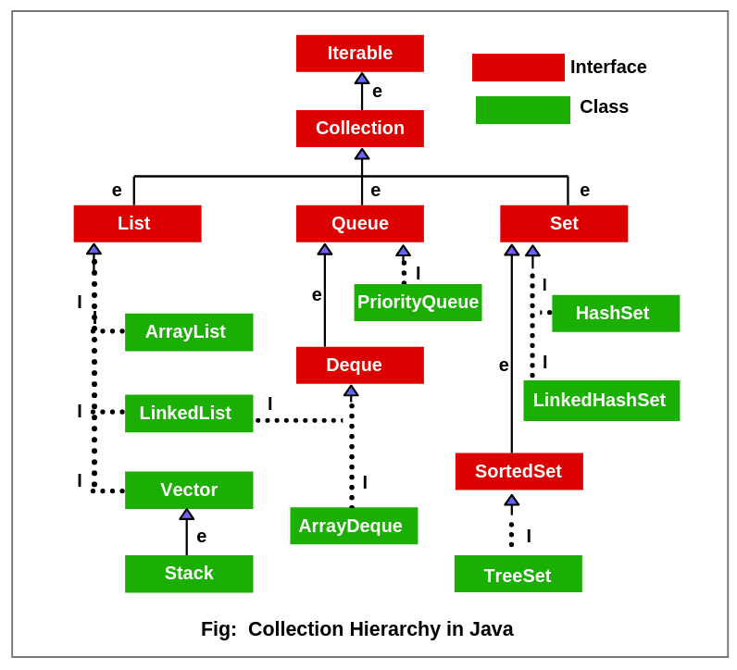

If we take any collection class. it provide dynamic memory. By default we can store any type of values. It provided lot of pre defined method which help to do different type of operation on those data like, add, remove, search, iterate, sort etc.
HashSet : HashSet is type of set class. HashSet keep the element in unorder like random.
LinkedHashSet : it is a type of set classes which internally extends HashSet. It maintain the order.
TreeSet : TreeSet is type of Set class. which internally implements SortedSet interface and that interface extends Set interface.SortedSet provide algorithms to do sorting the elements. By nature TreeSet allow homogeneous element
List classes
ArrayList : normal Array Vs ArrayList
- Normal array allow to store homogeneous element but by nature ArrayList allow to store heterogeneous element.
- Normal array is known as fixed in memory size. But ArrayList is known as dynamic memory size.
- Normal array adding or deleting element in between more complex. But ArrayList provided lot pre defined method we can add or remove the element in between very easily.
- Normal array doesn’t provide any pre defined method to do any operation on those values. But ArrayList provided set of methods which help to many operation on those data.

